**EX 6:**

**IMPLEMENT PROGRAM TO APPLY MOVING AVERAGE SMOOTHING FOR DATA PREPARATION AND TIME SERIES FORECASTING.**

**DATE:**

**AIM:**

To smooth time series data using a moving average for trend elimination and apply it for forecasting future values.

**ALGORITHM:**

1. Load the dataset and read it into a Pandas DataFrame.
2. Convert the Date column to datetime format and set it as the index.
3. Plot the original time series to visualize trends and fluctuations.
4. Apply moving average smoothing with a rolling window to reduce noise.
5. Plot the smoothed data alongside the original time series.
6. Use moving average to predict future values for the next 12 months.
7. Plot the forecasted values along with the original and smoothed data.

**PROGRAM:**

**import pandas as pd**

**import numpy as np**

**import matplotlib.pyplot as plt**

**# Load dataset**

**file_path = "/content/airline-passengers (1).csv"**

**df = pd.read_csv(file_path)**

**# Display first few rows**

**print(df.head())**

**# Ensure 'Date' column is in datetime format**

**df.columns = ['Date', 'Passengers'] # Rename columns if necessary**

**df['Date'] = pd.to_datetime(df['Date'])**

**df.set_index('Date', inplace=True)**

**# Plot original time series**

**plt.figure(figsize=(12,5))**

**plt.plot(df, label="Original Data")**

**plt.title("Original Time Series Data")**

**plt.xlabel("Time")**

**plt.ylabel("Passengers")**

**plt.legend()**

**plt.show()**

**# --- Moving Average Smoothing for Data Preparation ---**

**window_size = 5 # Change this for different levels of smoothing**

**df['Smoothed'] = df['Passengers'].rolling(window=window_size, center=True).mean()**

**# Plot smoothed data**

**plt.figure(figsize=(12,5))**

**plt.plot(df['Passengers'], label="Original Data", alpha=0.5)**

**plt.plot(df['Smoothed'], label="Smoothed Data (Moving Average)", color='green')**

**plt.title(f"Moving Average Smoothing (Window Size = {window_size})")**

**plt.xlabel("Time")**

**plt.ylabel("Passengers")**

**plt.legend()**

**plt.show()**

**# --- Time Series Forecasting Using Moving Average ---**

**# Predict the next 12 months using moving average**

**future_steps = 12**

**last_window = df['Passengers'].iloc[-window_size:].mean()**

**forecast = [last_window] * future_steps**

**future_dates = pd.date_range(start=df.index[-1], periods=future_steps+1, freq='M')[1:]**

**# Create forecast dataframe**

**forecast_df = pd.DataFrame({'Date': future_dates, 'Forecast': forecast})**

**forecast_df.set_index('Date', inplace=True)**

**# Plot forecasted values**

**plt.figure(figsize=(12,5))**

**plt.plot(df['Passengers'], label="Original Data", alpha=0.5)**

**plt.plot(df['Smoothed'], label="Smoothed Data", color='green')**

**plt.plot(forecast_df, label="Forecast (Moving Average)", color='red', linestyle='dashed')**

**plt.title("Time Series Forecasting Using Moving Average")**

**plt.xlabel("Time")**

**plt.ylabel("Passengers")**

**plt.legend()**

**plt.show()**

**OUTPUT:**

**Month Passengers**

**0 1949-01 112**

**1 1949-02 118**

**2 1949-03 132**

**3 1949-04 129**

**4 1949-05 121**

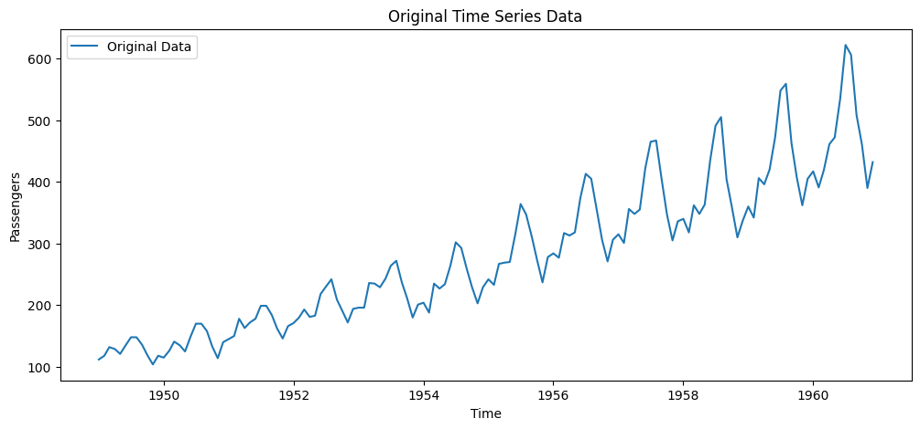

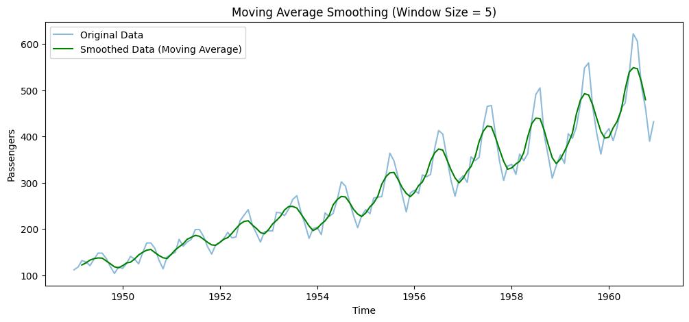

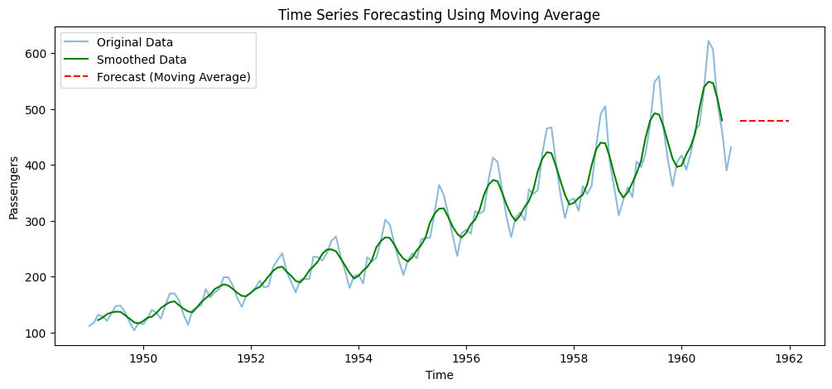

**RESULT:**

The program successfully smooths the time series data using a moving average and generates reasonable future predictions based on historical trends.